TPRSS DataSet Verification Architecture
Author | Revision Number | Date
architect | 1.0 | 05 December 2012

TPRSS DataSet Verification Architecture 1
1. Design 3
1.1 Work Flow Description 3
1.2 Component Requirements 3
1.2.1 New TopCoder Software Components 3
1.2.2 Existing TopCoder Software Components 3
1.2.3 Assemblies 3
1.3 PDF parsing Strategy 3
1.3.1 Writing to output text file 7
1.4 Word parsing Strategy 8
1.4.1 Writing to output text file 9
1.5 Comparison Strategy 11
2. Application Management 12
2.1 Configuration 12
2.2 Threading 12
2.3 Concurrency 13
2.4 Logging 13
2.5 Persistence 13
2.6 Security 13
2.7 Transactionality 13
2.8 Exception Handling Overview 13
2.9 Performance 13
2.10 Internationalization 13
3. Changes to the existing system 13
4. Deployment Constraints 13
5. Interfaces Classes Overview 14
6. User Interface 14
7. Included Documentation 14
7.1 Architecture Documentation 14

Design
Client needs a desktop application that conducts a review and verification of dataset access attributes. The application will allow us to import 5 (can be more or less) reference files and 1 master document. The application will return a new file that provides a summary of changes made to the master file.

A POC is already provided. See the main method of the Main.java. Currently the POC prints the dataset data parsed from all 5 PDFs into output/Pdf.txt and the dataset data parsed from the word document into the output/Word.txt
The POC contains only the dataset parsing part (in full), but the intent is to show the usage of Apache POI HWPF for Word parsing and Apache PdfBox for PDF parsing.

Work Flow Description

The basic workflow is as follows:
- The user launches the TPRSSSwingApplication class main method.
- The main method displays the GUI from where user can select the PDF files, the master MS Word file and the location of output file.
- The user will then press the Submit button which will internally call the TPRSSDataSetParser.process method
- In this method, the PDF documents will be parsed, the word document will be parsed, the data will be compared and the output file will be written
- The TPRSSDataSetParser.process method returns and either a success or error message will be displayed.

Component Requirements

New TopCoder Software Components
None

Existing TopCoder Software Components
None

Assemblies
TPRSS DataSet Verification GUI Assembly – This contest is a simple assembly which required a Java Swing based GUI to be developed which will act as the desktop application.
TPRSS DataSet Verification Core Assembly – This contest will contain the main logic of the system. It will contain the PDF and Word parsing, data verification and data output.

Third Part Libraries
- log4j 1.2.17
- Apache POI 3.8
- Apache PdfBox 1.7.1

PDF parsing Strategy

Apache PDFBox will be used for parsing PDF. iText is not used because the examples for the community version are hard to find and documentation is sparse.
The PDF file contains of a bunch of operators along with their arguments. This page shows all operators of PDF format.
The operators that we will use to extract data are the TJ operator and the Tf operator. The former is used for writing text and the latter is used for setting font information.
The parameters of the TJ operator consist of an array of Strings and Floats. The Strings are the text and the Floats are the amount in thousands of unit text space to move before typing the next String. A negative value moves the cursor to the right and a positive value moves the cursor to the left.
The Tf operator takes two parameters, one is the font style name and the other is font size.

The general algorithm to parse the datasets from PDF is as follows (this algorithm is already implemented in provided POC):
- Go through each PDF and in each PDF go through each page and in each page go through each PDF operator
- If operator is not Tf or TJ, then continue to next operator
- If operator is Tf, then parse the content of the font and store it in the current font size and current font style variables.
- If operator if TJ, then extract the text from the TJ. See important note 1 below to see the structure of a TJ
- If the text starts with DATASET, then extract the dataset name and store it in the currentDataSet variable
- If the text starts with User(s)withaccess, then the value of the next TJ will be the access value.
- If the text starts with GroupswithAccess, then the value of the next TJ will be the access value.
- If the User(s)withaccess text was found and now the UseridNameOwnerIdent.St.Sec.byCondition is found, then this means we are the start of the table which contains the users
- If the GroupswithAccess text was found and now the OwnerIdent.byConditionconnecteduserssee is found, then this means we are the start of the table which contains the groups.
- For each line in the table i.e. each subsequent TJ, extract the UserId or Group.
- If the font is not the correct font which is used to write the table rows, then ignore the text. The font that we will use is { R21, 6.58776f}
- Now insert the userid or group, into the pdfDataSets map with the currentDataSet as key and the {userid/group, access, user or group} as a new value in the list.

IMPORTANT NOTE 1: In the provided PDF, many times, all text on one line is written one character at a time and all spacing is done using floats of TJ (as explained above). This means that there is no concept of separate words. This makes the parsing especially difficult.
To give an example, consider the following screenshot of a fragment from the PDF:
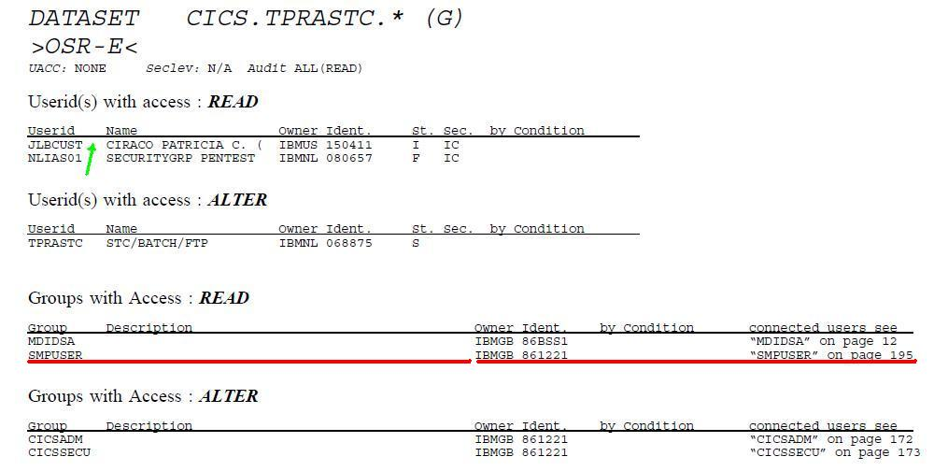
Figure 1

Let’s take the first row of the userid with access read. The entire text for the row is printed together using a TJ operator. The parameters for the TJ are:
J -1.11513 L -1.11513 B -1.11513 C -1.11513 U 17.1005 S -1.11513 T -1804.46 C -1.11513 I -1.11513 R -1.11513 A -1.11402 C -1.11402 O -602.229 P -1.11402 A -1.11402 T -1.11402 R -1.11402 I 17.1016 C -1.11402 I -1.11402 A -602.229 C -1.11402 . -602.229 ( -1203.34 I -1.11402 B -1.11402 M -1.11402 U -1.11402 S -602.229 1 17.1016 5 -1.11402 0 -1.11402 4 -1.11402 1 -1.11402 1 -3006.69 I -1804.46 I -1.11624 C
If we simply parse the text, we will get JLBCUSTCIRACOPATRICIAC.(IBMUS150411IIC
As can be noticed, there is no concept of a word. So we don’t know where the userid column ends and the name column starts. The only way of differentiating this is by using the fact that the cursor is moved quite a lot from where the userid value ends (JLBCUST) and the Name value starts (CIRACO…). This is highlighted by green arrow and the green text as shown above. We will use the fact that value is much larger than the ones before it, so this large value acts a delimiter for the words.

IMPORTANT NOTE 2: In the provided PDFs, in case of the table containing the group data, each row is not printed using one TJ (as is the case in the case of user data) above. It is in fact printed using 2 TJs. One contains the Group & Description part. The other contains the Owner, Ident, by Condition and connected users part. This is shown using the 2 red bars in the image above.
So while parsing the group data, we need to be aware that every alternate TJ is of no use of us.

IMPORTANT NOTE 3: In general, each dataset consists of the following format:
DATASET <name>
Userid(s) with access: <access>
<tabular data>
Groups with access: <access>
<tabular data>
However there are some special cases where this might not be the case, and which can break our algorithm.
The first case is that a dataset might not have any data at all. However the dataset must still be recorded, as the Word document might have some data. Here is a screenshot of this case:
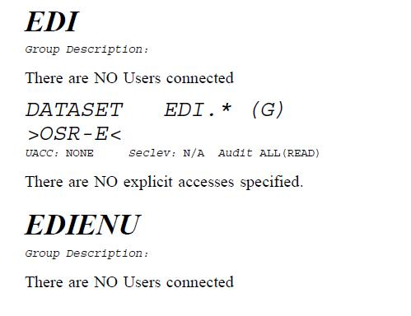 Figure 2

The second case is about knowing when to stop reading the data for a user or group. For example in the following image, after reading the MDIDSA group, we might also mistakenly read the CISC text as another group. The simplest way to avoid this is to observe that the fonts used for MDIDSA and CISC are different.
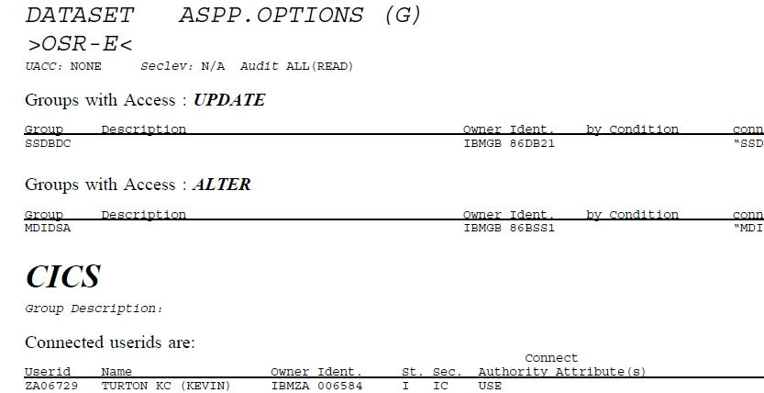
Figure 3

The third case is in some cases where there is a page change. In the example below, we see a line of text containing the word “Connect” in the new page. We need to differentiate this from the data that ends in the previous page. We cannot do so by font because the font is the same. We can do so by calculating the position of the text, but this is quite tedious in PDF. For now, we will simply assume that any text that contains lowercase letters cannot be a userid or group. Developer must confirm this from client.
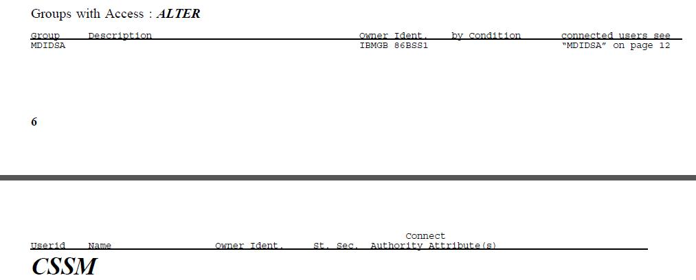
Figure 4

The general algorithm to parse the groups & connected users from PDF, is as follows:
- Go through each PDF and in each PDF go through each page and in each page go through each PDF operator
- If operator is not Tf or TJ, then continue to next operator
- If operator is Tf, then parse the content of the font and store it in the current font size and current font style variables.
- If operator if TJ, then extract the text from the TJ. See important note 1 below to see the structure of a TJ
- The group name is written in biggest font (for example, see CICS in Figure 3). If the font is {R14, 16.9411}, then we know this is a group name. Store the name as currentGroupName
- If the text starts with UseridNameOwnerIdent.St.Sec.AuthorityAttribute(s), means we are the start of the table which contains the connected users
- For each line in the table i.e. each subsequent TJ, extract the Userid, name, ownerIdent, St., Sec. and ConnectAuthorityAttributes columns
- If the font is not the correct font which is used to write the table rows, then ignore the text. The font that we will use is { R21, 6.58776f}
- For each row, write the entry into pdfConnectedUsers where currentGroupName is key and the {Userid, name} are added to the List<ConnectedUser> value for the given key.

Writing to output text file
The created pdfDataSets and pdfConnectedUsers maps will be written to text file. This text file will finally be used for comparison. The format for the text file is as follows:
<foreach key in pdfDatasets>
Dataset: <key>
<foreach AccessInfo in pdfDatasets[key]>
Id: <accessInfo.id>
Access: <accessInfo.access>
Type: <UID or GRP> (based on value of <accessInfo.userVsGroup>)
</foreach>
</foreach>
<empty line>
<foreach key in pdfConnectedUsers>
Group: <key>
<foreach ConnectedUser in pdfConnectedUsers[key]>
UserId: <connectedUser.userId>
Name: <connectedUser.name>
OwnerIdent: <connectedUser.ownerIdent>
St: <connectedUser.st>
Sec: <connectedUser.sec>
Connect Authority Attributes: <connectedUser.connectAuthorityAttributes>
</foreach>
</foreach>

For example, the contents of the text file, for groups ASPP and CICS (and related datasets) from Page 21, 22 of 86BSS1.pdf, is as follows:
Dataset: ASPP.*(G)
Id: SYSUSER
Access: UPDATE
Type: GRP
Id: MDIDSA
Access: ALTER
Type: GRP
Dataset: ASPP.MODEL(D)
Id: MVS
Access: READ
Type: GRP
Dataset: ASPP.OPTIONS(G)
Id: SSDBDC
Access: UPDATE
Type: GRP
Id: MDIDSA
Access: ALTER
Type: GRP

Group: ASPP
Group: CICS
UserId: ZA06729
Name: TURTON KC (KEVIN)
OwnerIdent: IBMZA 006584
St: I
Sec: IC
ConnectAuthorityAttributes: USE
UserId: ZA08533
Name: DUIMPIES A (ALLISTER
OwnerIdent: IBMZA 006584
St: I
Sec:
ConnectAuthorityAttributes: USE

Word parsing Strategy
Apache POI HWPF will be used for parsing through the Word document.
The word parsing is done by first getting the document’s range and then getting all the Paragraph entities from it. The Paragraph entities will contain all the data we need. Some important observations about the Word parsing are:
- In Word, a table is just a Paragraph with certain attributes set. There is no way to get the tables as such. Instead we look at each Paragraph and check if there is a table associated with it. If so, then we get the Table instance on which we can operate further.
- In the HWPF Table, the number of rows is not the visible number of rows but instead the sum of the number of entries in the User/Group Access column.
- The entries are delimited using the BEL character (0x07).

The data will be read from the Word document and will be written to the wordDataSets, wordGroupsUsersDefs and wordConnectedUsers map. The basic logic is as follows:
- The table containing the datasets is parsed and the contents are written to the wordDataSets map.
- The groups and users at the start of section 3.1 (titled Groups/Userids definitions) are read into the wordGroupsUsersDefs map.
- The groups and connected user tables (which are located after the table containing the datasets) are read and the contents are written to the wordConnectedUsers map.
- The contents of all these maps are written to the output temporary text file.

Writing to output text file
The created wordDataSets, wordGroupsUsersDefs and wordConnectedUsers maps will be written to text file. This text file will finally be used for comparison. The format for the text file is as follows:
<foreach key in wordDatasets>
Dataset: <key>
<foreach AccessInfo in wordDatasets[key]>
Id: <accessInfo.id>
Access: <accessInfo.access>
Type: <UID or GRP> (based on value of <accessInfo.userVsGroup>)
</foreach>
</foreach>
<empty line>
<foreach value in wordGroupsDefs>
Group Definitions:
<value>
</foreach>
<empty line>
<foreach value in wordUserDefs>
User Definitions:
<value>
</foreach>
<empty line>
<foreach key in wordConnectedUsers>
Group: <key>
<foreach ConnectedUser in wordConnectedUsers[key]>
UserId: <connectedUser.userId>
Name: <connectedUser.name>
OwnerIdent: <connectedUser.ownerIdent>
St: <connectedUser.st>
Sec: <connectedUser.sec>
Connect Authority Attributes: <connectedUser.connectAuthorityAttributes>
</foreach>
</foreach>

A sample text file, for the first 2 each of datasets, group defs, user defs and group connected users in the sample word document, is as follows:
Dataset: JLBCUST.*(G)
Id: FTPJLB1
Access: READ
Type: UID
Id: TPRSDBA
Access: READ
Type: UID
Id: TPRSFTP
Access: READ
Type: UID
Id: JLBBTCH
Access: ALTER
Type: UID
Id: CAPRI
Access: READ
Type: GRP
Dataset: JLBCUST.*.* (G)
Id: TPRSDBA
Access: READ
Type: UID
Id: JLBBTCH
Access: ALTER
Type: UID

Group Definitions:
ADMCOP0
BAS

User Definitions:
#WDC1
DBBATCH

Group: ADMCOP0
UserId: LSCSUP
Name: VASANT ARUN K
OwnerIdent: IBMIN 919864
St: I
Sec:
ConnectAuthorityAttributes: CREATE
UserId: RWYQLDP
Name: TIE INTERF. IMS-DB2
OwnerIdent: IBMNL 068875
St: S
Sec:
ConnectAuthorityAttributes: USE
UserId: ZA06729
Name: TIE INTERF. IMS-DB2
OwnerIdent: IBMNL 068875
St: S
Sec:
ConnectAuthorityAttributes: USE
UserId: SCCIM5
Name: LUBBERS A (ATY)
OwnerIdent: IBMNL 045351
St: I
Sec:
ConnectAuthorityAttributes: USE
Group: BAS
UserId: DBBATCH
Name: DBA BATCH USER
OwnerIdent: IBMZA 003365
St: S
Sec: IC
ConnectAuthorityAttributes: USE
UserId: FTOPC00
Name: FTP-USERID
OwnerIdent: IBMZA 006339
St: S
Sec: IC
ConnectAuthorityAttributes: USE
UserId: FTPIDDE
Name: FTP-USERID
OwnerIdent: IBMZA 006339
St: S
Sec: IC
ConnectAuthorityAttributes: USE
UserId: OPCTRIG
Name: OPC TRIGGER USERID
OwnerIdent: IBMNL 008875
St: S
Sec:
ConnectAuthorityAttributes: USE

Comparison Strategy
Once the Word and PDF parsing is done and their contents are written to the temporary output files, the final comparison is made between the Word and the PDF data.
The PDF temp file, Word temp file and output report file are passed as parameters and the comparison method writes the comparison report to the output file.
The logic is as follows:
- Read the PDF temp file and parse is back into pdfDataSets and pdfConnectedUsers map (This is just the reverse logic of section 1.3.1)
- Read the Word temp file and parse is back into wordDataSets, wordUserDefs, wordGroupDefs and wordConnectedUsers map (This is just the reverse logic of section 1.4.1)
- Now the wordDataSets is compared to the pdfDataSets map. The logic is as follows:
- For each dataset in wordDataSets
  - Check if dataset exists in pdfDataSets map. If not, write to output file, “Dataset <dataset> does not exist in any reference document”
  - For each wordAccessInfo in wordDataSets[dataset]
    - In pdfDataSets[dataset] list, find the accessInfo which matches the wordAccessInfo.user and wordAccessInfo.userVsGroup.
    - If found, set accessInfo.visited = true. Then check if the wordAccessInfo.access is the same as the accessInfo.access. If not, write to output file, “Access of <User/Group> <id> for Dataset <row.dataset> is not matching. Master file contains <row.mismatch> and reference file contains <accessInfo.mismatch>”
    - If not found, write to output file, “<User/Group> <id> for Dataset <row.dataset> does not exist in any reference file”
- For each key in pdfDataSets
  - For each AccessInfo in pdfDataSets[key]
    - If AccessInfo.visited == false, then write to output file “<User/Group> <id> for Dataset <key> does not exist in the master file”
- Next the users/groups in wordDatasets map are compared to the data in the wordGroupDefs and wordUserDefs. Each group/user in the wordGroupDefs and wordUserDefs map must exist in the wordDatasets map and vice versa.
- For each AccessInfo element in each dataset of wordDatasets
  - Check if it is a group or user. If it does not exist, in the wordGroupDefs and wordUserDefs map (depending on whether it is user or group), then write to output file “<User/Group> <id> for Dataset <key> does not exist in the Groups/UserIds definitions section”
- For each group or user in wordGroupDefs and wordUserDefs map
  - Check if it exists, in the wordDatasets map. If not, then write to output file “<User/Group> <id> does not exist in the Datasets table of master file”
- Next the wordConnectedUsers map is compared to the pdfConnectedUsers map. The logic is as follows:
- For each group (key) in wordConnectedUsers
  - Check if group (the key) exists in pdfConnectedUsers map. If not, write to output file, “Group <group> does not exist in any reference document”
  - For each cu:ConnectedUser in wordConnectedUsers[key]
    - In pdfConnectedUsers[key] list, find the element where connectedUser.userId matches the cu.userId
    - If found, set connectedUser.visited = true.
Check if the cu.name is the same as the connectedUser.name. If not, write to output file, “Name of User <connected_user_id> is not matching. Master file contains <cu.name> and reference file contains <connectedUser.name>”
Check if the cu.ownerIdent is the same as the connectedUser.ownerIdent. If not, write to output file, “Owner Ident of User <connected_user_id> is not matching. Master file contains <cu.ownerIdent> and reference file contains <connectedUser.ownerIdent>”
Similarly check the st, sec and connectAuthority attributes fields also.
    - If not found, write to output file, “User <connected_user_id> does not exist in any reference file”
- For each key in pdfConnectedUsers
  - For each ConnectedUser in pdfConnectedUsers[key]
    - If ConnectedUser.visited == false, then write to output file “User < ConnectedUser.userId> does not exist in the master file”

Application Management

Configuration
Properties file will be used for configuration.
There are 3 possible configuration properties in the TPRSSSwingApplicationPanel:
- TprssDataComparer – The full class name of the instance of TprssDataComparer to be used.
- TprssPdfParser - The full class name of the instance of TprssPdfParser to be used.
- TprssWordParser - The full class name of the instance of TprssWordParser to be used.
The TPRSSSwingApplicationPanel will create the TprssDataComparer, TprssPdfParser and TprssWordParser using reflection. It is assumed that all these classes will have a default constructor.

Threading
The GUI itself is shown in a separate thread.
The call to TPRSSDataSetParser is currently not planned to be made in a separate thread. The current POC parses through 5 PDFs and the Word document in less than 2 seconds, so GUI will not be blocked for long.
However it must be noted that no class in the system is ever accessed concurrently from more than 1 thread. So thread-safety is not a concern.

Concurrency
There are no specific concurrency concerns.
It is assumed that the PDFs and the Word documents will not be accessed by any other process while the application is in use.
The same output document must not be specified in 2 concurrent runs of the application, this will result in unexpected behavior.

Logging
log4j will be used as logger for both the GUI and the TPRSSDataSetParser.
Method entry (with parameters) and exit (with return value) must be logged. (INFO level)
Exceptions should be logged. (ERROR level)
Logging is required only in the public methods.
Note - The output report file is actually a comparison log of dataset changes

Persistence
NA

Security
NA

Transactionality
NA

Exception Handling Overview
Exceptions will be thrown by the TPRSSDataSetParser. The exception message should be end-user friendly. The TPRSSDataSetParserException will wrap any exceptions while parsing through the PDF or Word document. Other exceptions such as file not found exception or errors while writing to the output file will be allowed to bubble through.
The GUI will catch all exceptions thrown by TPRSSDataSetParser and show the exception message to the end-user. The GUI itself will not throw any exception.

Performance
Each PDF is traversed strictly in forward only manner. Only one scan is needed. Most PDF operators are rejected straight away. So traversing the PDF is as fast as possible.
Once the PDF is parsed, the parsed data is stored in an in-memory map. This way when the word document is parsed, it can look straight into the in-memory map for fast access.

Internationalization
NA

Changes to the existing system
NA

Deployment Constraints
- Java 1.6
- Swing
- log4j 1.2.17
- Apache POI 3.8
- Apache PdfBox 1.7.1

Interfaces Classes Overview
See TCUML

User Interface
See TPRSS DataSet Verification GUI assembly spec for the detailed GUI requirements. The GUI will be a desktop based application based on Swing.

Included Documentation

Architecture Documentation
- Interfaces Class Diagrams
- Sequence Diagrams
- Application Design Specification
- Assembly Requirement Specification

